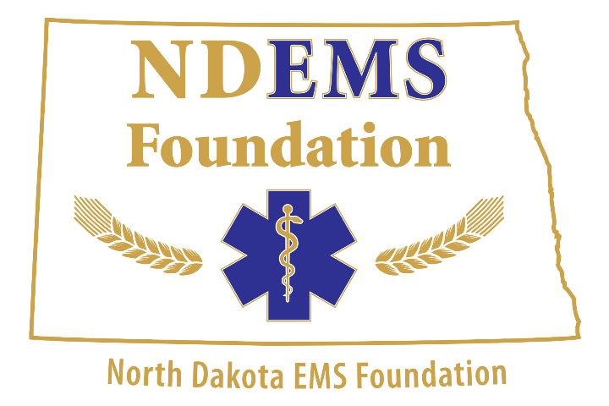
2018 NDEMS Foundation Fishing Tournament Registration Form
Captain’s First Name: _______________________ Last Name: _____________________________
Captain’s Address: _____________________________________________________________________
Captain’s City: _____________________________ State: __________ Zip: _______________
Captain’s E-Mail Address: _______________________________________________________________
Captain’s Home Phone: ___________________________ Cell: ____________________________

Partner’s First Name: ________________________ Last Name: _____________________________
Partner’s Address: _____________________________________________________________________
Partner’s City: _____________________________ State: __________ Zip: _______________
Partner’s E-Mail Address: _______________________________________________________________
Partner’s Home Phone: ___________________________ Cell: ____________________________
If under the age of 18, Parent/Guardian’s Signature: __________________________________________

Fishing Tournament Fee: $250.00
Banquet/Rules Meeting Fee (MANDATORY): $ 50.00
(One member of each team MUST be at the banquet)

Additional Angler Fee: $35.00 per angler $
Additional Angler registration forms must be attached to this registration form.
Total Registration Fee: $

ALL TEAMS ARE RESPONSIBLE FOR CLEANING THEIR OWN CATCH, BRING ANY
EQUIPMENT YOU WILL NEED TO CLEAN YOUR CATCH!!!

